Lab Assignment 5: Navigation Bars and Repeated Images
Deliverable: Four (4) Web pages (the home page and three image pages) and four (4) Cascading Style Sheets (.css) (one for each page)

Complete the weekly lab based on the following:

- Write the code for each lab assignment.
- The code is to be submitted in a single compressed folder (zip file) to the online course shell. The file must contain all .htm files, along with any other files that may be necessary for your project to run (ex: text files, images, etc.).
- When saving the file, it should be saved as Lab_#5_Maysonet_W.htm.
- Any and all written answers must be entered into the online course shell with the submission of the attached lab assignment.
Follow the directions below to complete Lab Assignment 5:
- Create a home page with navigation bar to the three (3) pages with images listed below and a Cascading Style Sheet (.css) for bisque color and Arial text.
- Create a “single image” page with a Cascading Style Sheet (.css) for background image, bisque color, and Arial text.
- Create a “top line image” page with Cascading Style Sheet (.css) for background image, bisque color, and Arial text.
- Create a “left side image” page with a Cascading Style Sheet (.css) for background image, bisque color, and centered Arial text.
- Below are example of what is should look like.
- 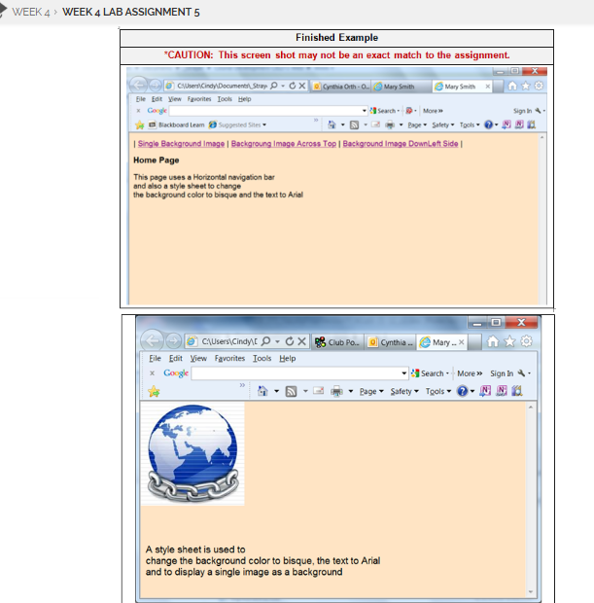
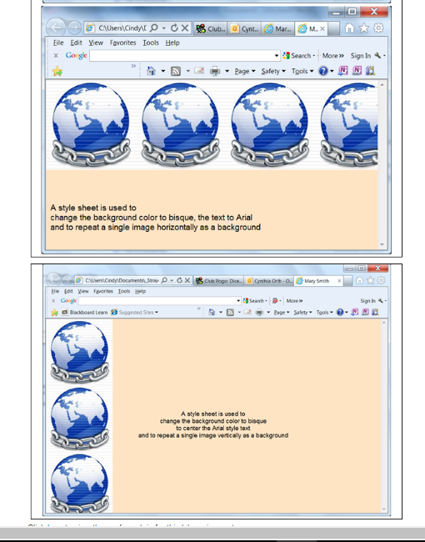

Lab Assignment 5: Navigation Bars and Repeated Images
Criteria | 0 points  Unacceptable | 5 points  Developing | 10 points  Sufficient
1. Create a home page with navigation bar to the three (3) pages with images listed below and a Cascading Style Sheet (.css) for bisque color and Arial text. | Did not complete. | Completed with errors. | Completed correctly.
2. Create a “single image” page with a Cascading Style Sheet (.css) for background image, bisque color, and Arial text. | Did not complete. | Completed with errors. | Completed correctly.
3. Create a “top line image” page with Cascading Style Sheet (.css) for background image, bisque color, and Arial text. | Did not complete. | Completed with errors. | Completed correctly.
4. Create a “left side image” page with a Cascading Style Sheet (.css) for background image, bisque color, and centered Arial text. | Did not complete. | Completed with errors. | Completed correctly.

